**Vintage-Style Dry Gin Bar Mirror**

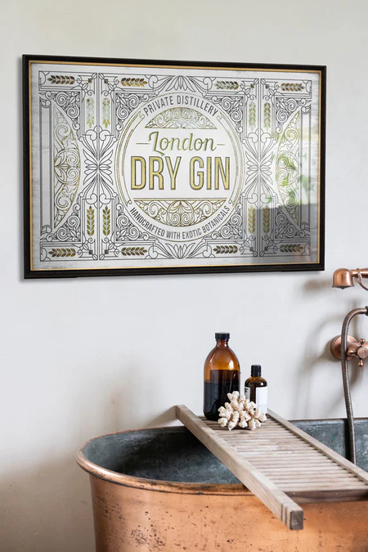The Vintage-Style Dry Gin Bar Mirror is a perfect fusion of nostalgic charm and functional elegance. Featuring a classic design with vintage typography, this mirror is an ideal addition to any bar area or home lounge. Its retro-inspired graphics and distressed finish evoke a sense of timeless sophistication, transporting you to the golden age of gin bars. The mirror not only serves as a decorative element but also adds depth and light to your space. Whether you’re hosting a gathering or enjoying a quiet drink, this piece brings an authentic touch of vintage flair and style to your home bar.